
Course Title Python Full Stack Development Academic Year : 2025 – 26 – Even Sem Course Code 24CS01EF Page 1 of 75

Full Stack Web Development Department of Computer Science & Engineering,
KLEF (Deemed to be University), Aziz Nagar, Hyderabad, Telangana



25SC2008E - Full Stack Web Development
Lab Workbook



25SC2008E - Full Stack Web Development
Lab Workbook

STUDENT NAME | D.Dhanush
REG NO | 2510040001
YEAR | 2nd year
SEMESTER | ODD
SECTION | 2
FACULTY NAME

Course Title | Full Stack Web Development | Academic Year : 2026 – 27 – Odd Sem
Course Code | 25SC2008E | Page 2 of 75

INDEX
Sl.No | Date of Execution | Title | Program  / Write – up [10] | Execution & Output [40] | Total [50] | Faculty Sign
1 |  | Analyze the architecture of an E-Commerce website and identify frontend, backend, and database components.
2 |  | Study the Full-Stack Web Architecture and trace HTTP Request-Response cycle.
3 |  | Build a Personal Portfolio Website using Semantic HTML5.
4 |  | Create a To-Do application using Vanilla JavaScript, DOM Manipulation, Event Handling, Fetch API, and Local Storage.
5 |  | Set up a Node.js and Express project implementing middleware, routing, and REST API endpoints.
6 |  | Develop a Student Management REST API using Express.js.
7 |  | Build a Notes Management API with CRUD Operations.
8 |  | Implement a Product Catalog using MongoDB and Mongoose.
9 |  | Create a Movie Collection CRUD Application with Database Integration.
10 |  | Build a Student Record Management System using MongoDB Atlas.
11 |  | Persistent Storage for Student Record Management System using MongoDB Atlas/ Prisma
12 |  | Implement JWT-based authentication with user registration, login, password hashing (bcrypt), and protected routes.
13 |  | Deploy React Frontend on Vercel and Node.js Backend on Render/Railway with environment variable configuration.
14 |  | Develop and deploy a complete Full-Stack Application using React, Express, Database (MongoDB/PostgreSQL), JWT Authentication, and Cloud Deployment.

Course Title | Full Stack Web Development | Academic Year: 2026 – 27 – Odd Sem
Course Code | 25SC2008E | Page 3 of 75

Course Title | Full Stack Web Development | Academic Year : 2026 – 27 – Odd Sem
Course Code | 25SC2008E | Page 4 of 75

KL University Vision and Mission
Vision :
To be a globally renowned university.

Mission :
To impart quality higher education and to undertake research and extension with emphasis on application and innovation that cater to the emerging societal needs through all-round development of the students of all sections enabling them to be globally competitive and socially responsible citizens with intrinsic values.

Course Title | Full Stack Web Development | Academic Year : 2026 – 27 – Odd Sem
Course Code | 25SC2008E | Page 5 of 75

Table of Contents
Experiment 1: Analyze the architecture of an E-Commerce website and identify frontend, backend, and database components 8
Scenario 8
Tasks 8
Expected Output 8
Viva Questions 10
Experiment 2: Study the Full-Stack Web Architectureandtrace HTTP Request-Response cycle.12
Scenario 12
Tasks 12
Expected Output 12
Viva Questions 14
Experiment 3: Build a Personal Portfolio Website using Semantic HTML5 16
Scenario 16
Tasks 16
Expected Output 16
Viva Questions 19
Experiment 4: To-Do app ( JavaScript, DOM, Fetch API, and Local Storage) 21
Scenario 21
Tasks 21
Expected Output 21
Viva Questions 23
Experiment 5: Node.js & Express ,middleware, routing, and REST API endpoints 25
Scenario 25
Tasks 25
Expected Output 25
Viva Questions 27
Experiment 6: Student Management REST API using Express.js 29
Scenario 29
Tasks 29
Expected Output 29
Viva Questions 31
Experiment 7: Notes Management API with CRUD Operations 33
Scenario 33
Tasks 33
Expected Output 33
Viva Questions 36
Experiment 8: Product Catalog using MongoDB and Mongoose 38
Scenario 38
Tasks 38
Expected Output 38
Viva Questions 42

Course Title | Full Stack Web Development | Academic Year : 2026 – 27 – Odd Sem
Course Code | 25SC2008E | Page 6 of 75

Experiment 9: Create a Movie Collection CRUD Application with Database Integration. 44
Scenario 44
Tasks 44
Expected Output 44
Viva Questions 47

Experiment 10: Student Record Management System using MongoDB Atlas 49
Scenario 49
Tasks 49
Expected Output 49
Viva Questions 52

Experiment 11: Using Atlas/ Prisma Persistent Storage with PostgreSQL (CRUD Operations) 54
Scenario 54
Tasks 54
Expected Output 54
Viva Questions 57

Experiment 12: Implement JWT-based User Authentication System 59
Scenario 59
Tasks 59
Expected Output 59
Viva Questions 62

Experiment 13: Deploy React Frontend and Node.js Backend 64
Scenario 64
Tasks 64
Expected Output 64
Viva Questions 66

Experiment 14: Full-Stack Application Deployment 68
Scenario 68
Tasks 68
Review 75

Course Title | Full Stack Web Development | Academic Year: 2026– 27– Odd Sem
Course Code | 25SC2008E | Page 7 of 75

Course Title | Full Stack Web Development | Academic Year : 2026 – 27 – Odd Sem
Course Code | 25SC2008E | Page 8 of 75

Date of Execution:

Experiment 1: Understand the architecture of a full-stack web application and trace HTTP requests using browser developer tools.

Scenario:

Analyze a website

Open any e-commerce website (Amazon, Flipkart, etc.).
Identify:
➤ FRONTEND COMPONENTS
──────────────────────────────────────────────
• HTML – Structure of web pages
• CSS – Styling and layout
• JavaScript – Interactivity and dynamic content
• Navigation bar and search bar
• Product listings and product details
• Shopping cart
• Login and checkout interface
➤ BACKEND SERVICES
──────────────────────────────────────────────
• User authentication
• Product management
• Search and filtering
• Shopping cart management
• Order processing
• Payment processing
• Inventory management
• API services

Course Title | Full Stack Web Development | Academic Year: 2026 – 27 – Odd Sem
Course Code | 25SC2008E | Page 9 of 75

➤ DATABASE USAGE
──────────────────────────────────────────
• User details
• Product details and prices
• Stock information
• Cart information
• Order details
• Payment and transaction records

➤ ARCHITECTURE DIAGRAM
──────────────────────────────────────────
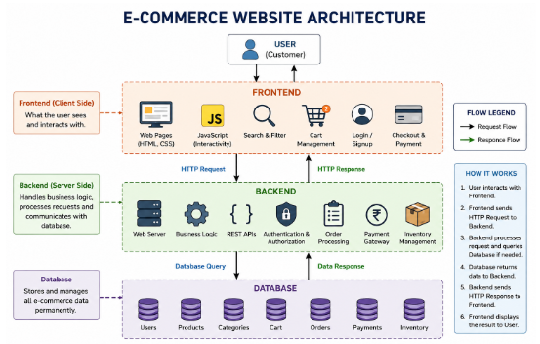
➤ EXPECTED OUTPUT
──────────────────────────────────────────────
Observe:
Request URL: https://www.amazon.in/
Request Method: GET
Status Code: 200 OK (from service worker)
Response Time: 1.44 s

➤ RESULT
──────────────────────────────────────────────
The architecture of the e-commerce website was analyzed successfully. The Frontend, Backend, and Database components
were identified, and HTTP requests were observed using browser Developer Tools.

Course Title | Full Stack Web Development | Academic Year: 2026 – 27 – Odd Sem
Course Code | 25SC2008E | Page 10 of 75

VIVA QUESTIONS

1. What is the difference between HTTP and HTTPS?

Answer:
HTTP transfers data between the browser and server without encryption.
HTTPS uses encryption to provide secure communication between the browser and server.

2. Name four HTTP methods and state their purpose.

Answer:
GET – Retrieves data from the server.
POST – Sends or creates data on the server.
PUT – Updates existing data on the server.
DELETE – Deletes data from the server.

3. Explain the meaning of HTTP status codes 200, 301, 404, and 500.

Answer:
200 – OK / Request was successful.
301 – Moved Permanently.
404 – Requested resource was not found.
500 – Internal Server Error.

4. What is the role of a database in a web application?

Answer:
A database stores and manages application data.
The backend can retrieve, insert, update, and delete data from the database.

5. What are cookies?

Answer:
Cookies are small pieces of data stored in the user's browser.
They are commonly used to store session information, preferences, and other user-related data.

6. What is session management?

Answer:
Session management is used to maintain a user's state and information across multiple requests
while using a web application.

7. What is the role of Browser Developer Tools?

Answer:
Browser Developer Tools are used to inspect webpages, debug HTML/CSS/JavaScript,
and monitor network requests, responses, status codes, and website performance.

Course Title | Full Stack Web Development | Academic Year: 2026 – 27 – Odd Sem
Course Code | 25SC2008E | Page 11 of 75

Evaluator Remark (if Any): | Marks Secured:
Evaluator Remark (if Any): | Signature of the Evaluator with Date
Course Title | Full Stack Web Development | Academic Year: 2026 – 27 – Odd Sem
Course Code | 25SC2008E | Page 12 of 75

Date of Execution:

Experiment 2: Study the Full-Stack Web Architecture and trace HTTP Request-Response cycle.
Scenario:
Students can:
- Understand Full-Stack Architecture.
- Analyze HTTP Request-Response Communication.
- Use Browser Developer Tools.
- Identify HTTP Methods and Status Codes.

Step 1
Open any website (Amazon, Flipkart, Wikipedia, etc.).

Step 2
Press F12 and open Developer Tools. Step 3
Select the Network tab.

Step 4
Refresh the webpage.

Step 5

Record any 5 requests
Expected Output:
Capture a screenshot of the Network Tab and identify:
- One GET Request
- One POST Request (if available)
- One Status Code 200 Response
- One Status Code 404 Response (if available)

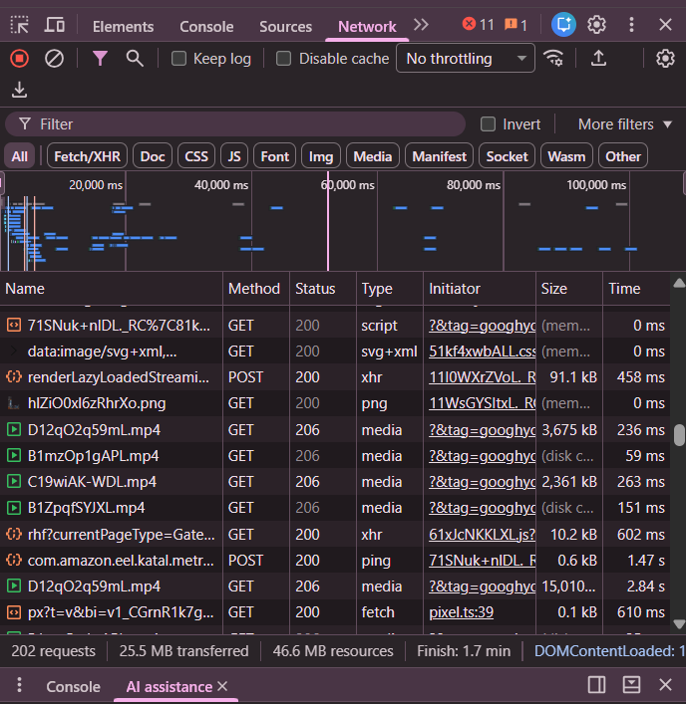
Course Title | Full Stack Web Development | Academic Year: 2026 – 27 – Odd Sem
Course Code | 25SC2008E | Page 13 of 75

OBSERVATION TABLE

S. No | Request / Resource | Method | Status Code | Type
1 | 71SNuk+nDL_RC%7C81k... | GET | 200 | Script
2 | data:image/svg+xml,... | GET | 200 | SVG+XML
3 | renderLazyLoadedStream... | POST | 200 | XHR
4 | hlZI...png | GET | 200 | PNG
5 | com.amazon... | POST | 200 | Ping

Course Title | Full Stack Web Development | Academic Year: 2026 – 27 – Odd Sem
Course Code | 25SC2008E | Page 14 of 75

VIVA QUESTIONS

1. What is DNS?

DNS stands for Domain Name System. It translates human-readable domain names,
such as www.google.com, into IP addresses that computers use to communicate over the Internet.

2. What is REST API?

REST API stands for Representational State Transfer Application Programming Interface. It is a way for applications to communicate with each other over HTTP using methods such as GET, POST, PUT, and DELETE.

3. Why is HTTPS more secure than HTTP?

HTTPS is more secure than HTTP because it encrypts the data transferred between the browser and the server using TLS/SSL. It protects sensitive information such as passwords and payment details from being intercepted.

4. Draw the Full-Stack Architecture Diagram.
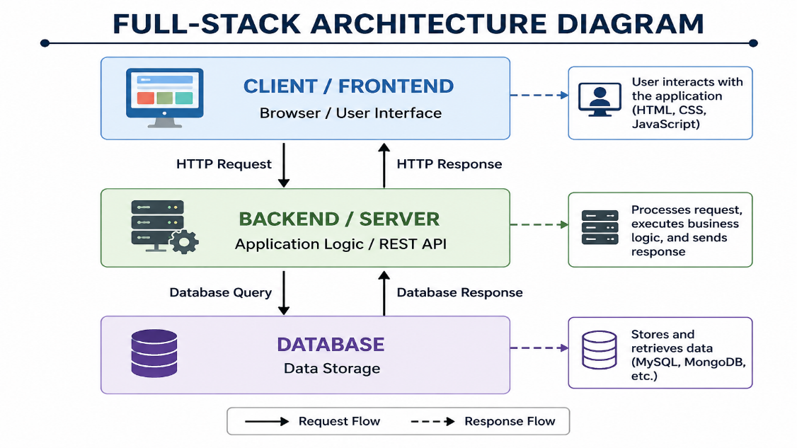

5. Write the steps in the HTTP Request-Response Cycle.
Step 1: The user enters a URL or performs an action in the browser.
Step 2: The browser finds the server's IP address using DNS.
Step 3: The browser sends an HTTP/HTTPS request to the server.
Step 4: The web server or backend receives and processes the request.
Step 5: The backend may communicate with the database to retrieve or store data.
Course Title | Full Stack Web Development | Academic Year: 2026 – 27 – Odd Sem
Course Code | 25SC2008E | Page 15 of 75

Step 6: The server sends an HTTP response containing a status code and requested data.
Step 7: The browser receives the response and displays the webpage or result to the user.

6. What is the difference between GET and POST?
GET is mainly used to request or retrieve data from a server. The data is usually sent through the URL as query parameters.
POST is mainly used to send or submit data to a server. The data is sent in the request body and is commonly used for forms, login, registration, and creating data.

Example:

GET → Retrieve data
POST → Send or submit data

Evaluator Remark (if Any): | Marks Secured:
Evaluator Remark (if Any): | Signature of the Evaluator with Date

Course Title | Full Stack Web Development | Academic Year : 2026– 27 – Odd Sem
Course Code | 25SC2008E | Page 16 of 75

Date of Execution:

Experiment 3: Personal Portfolio Using Semantic HTML5

Scenario:

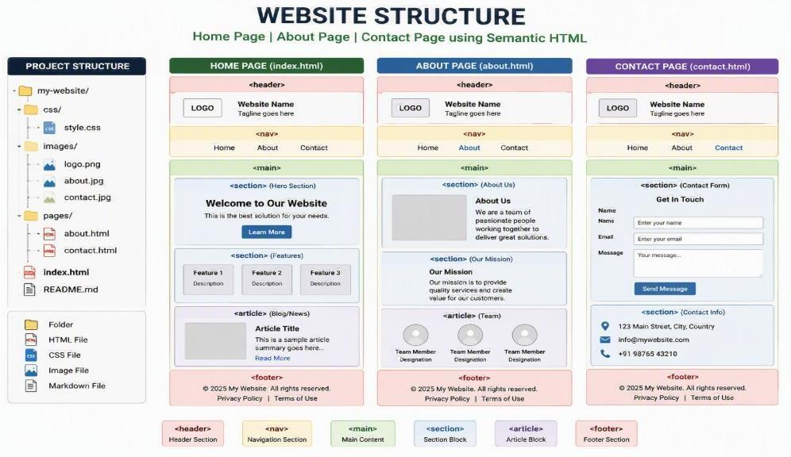

Tasks:
Responsive multi-page-Semantic HTML5, CSS Flexbox, Grid, CSS Variables, and Media Queries.

Task 1: Create Website Structure
Develop the following pages:
- Home Page
- About Page
- Contact Page
Use Semantic HTML elements:
  - <header>
  - <nav>
  - <main>
  - <section>
  - <article>
  - <footer>

Course Title | Full Stack Web Development | Academic Year : 2026– 27 – Odd Sem
Course Code | 25SC2008E | Page 17 of 75

Task 2: Implement Responsive Layout
Apply:
- Flexbox for navigation menu
- CSS Grid for content sections
- CSS Variables for color themes
- Media Queries for mobile, tablet, and desktop view

Task 3: Validate Responsiveness

Test website at:
Device Type | Screen Width
Mobile | ≤ 768px
Tablet | 769px – 1024px
Desktop | > 1024px

Task 4: Observe and Record
Item | Observation
Semantic Tags Used
Flexbox Applied To
Grid Applied To
CSS Variables Defined
Media Query Breakpoints

Expected Output:

Three linked webpages Responsive navigation bar Responsive content layout Mobile-friendly design Proper semantic structure

Course Title | Full Stack Web Development | Academic Year: 2026– 27 – Odd Sem
Course Code | 25SC2008E | Page 18 of 75

Figure 1: Home Page
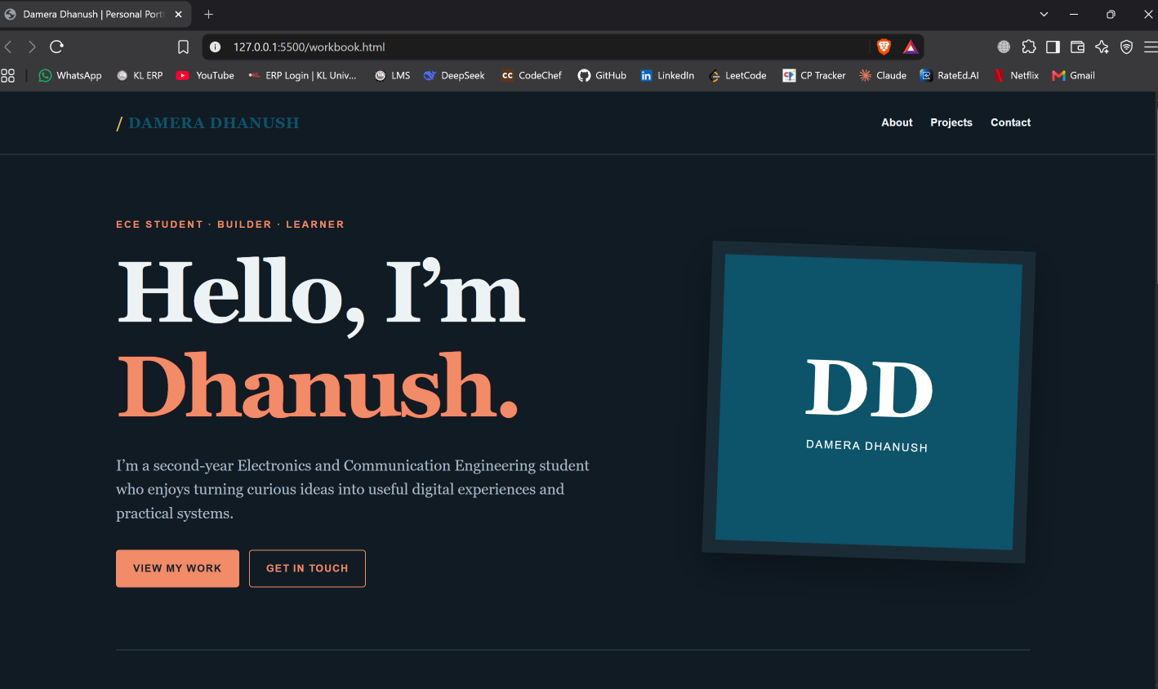

Figure 2: About Page

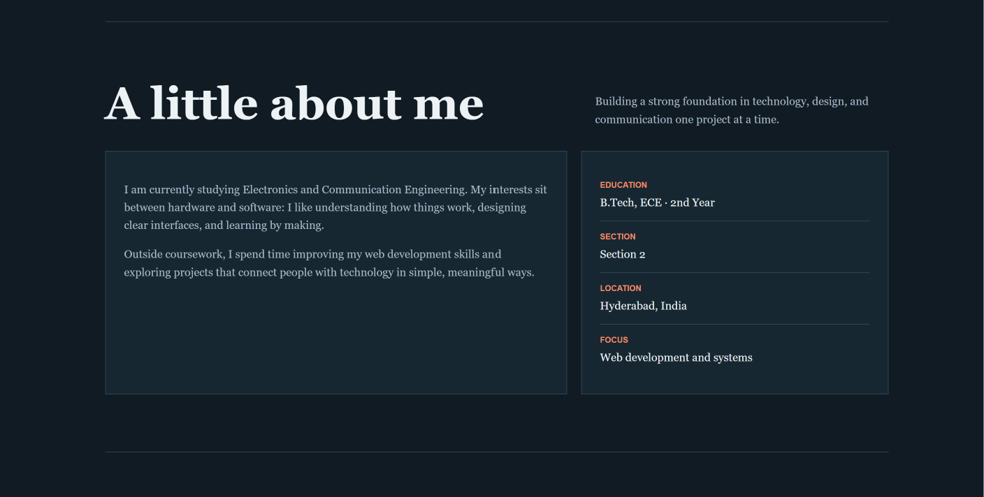

Course Title | Full Stack Web Development | Academic Year: 2026– 27 – Odd Sem
Course Code | 25SC2008E | Page 19 of 75

Figure 3: Mobile Responsive View

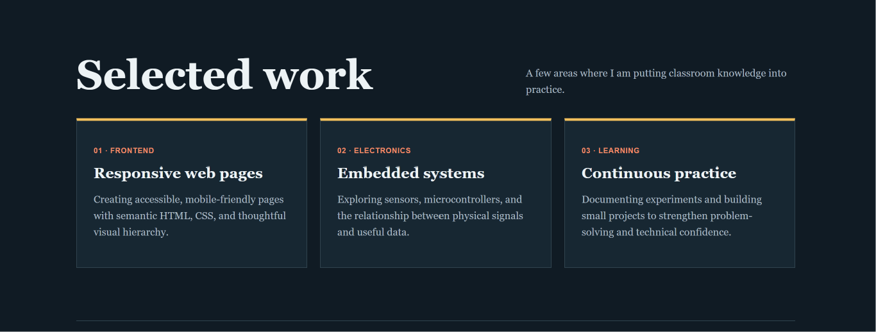

Figure 4: Contact Page
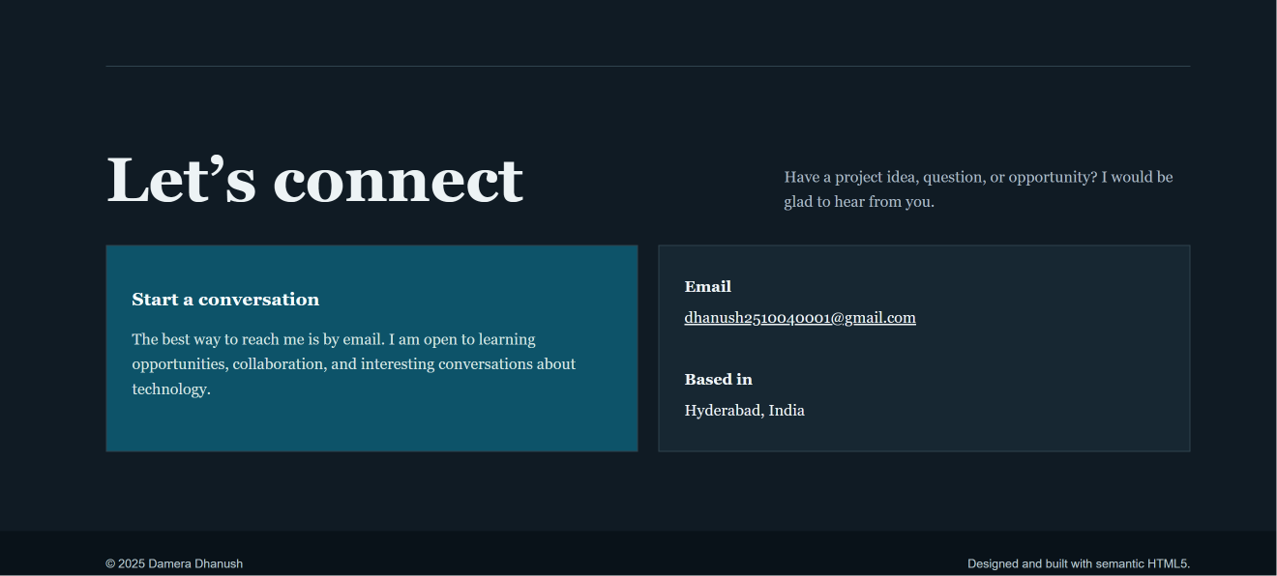

Course Title | Full Stack Web Development | Academic Year : 2026– 27 – Odd Sem
Course Code | 25SC2008E | Page 20 of 75

<header> → Top/header area of the webpage
<nav> → Navigation links
<main> → Main content of the webpage
<section> → Groups related content
<article> → Independent content such as a blog or project
<footer> → Bottom section of the webpage

VIVA QUESTIONS AND ANSWERS

1. What is the viewport in web design?

The viewport is the visible area of a webpage on a device screen. It changes according to the screen size of the device.
The viewport meta tag is used to make a webpage responsive on mobile devices.

2. What is the difference between px, %, em, and rem units?

px (Pixel): A fixed unit used to specify an exact size.

% (Percentage): A relative unit based on the size of the parent element.

em: A relative unit based on the font size of the parent element.

rem: A relative unit based on the font size of the root HTML element.

3. What is the CSS Box Model?

The CSS Box Model is a concept that describes how every HTML element is represented as a rectangular box.
It consists of content, padding, border, and margin.

4. What are the components of the Box Model?

The four components of the CSS Box Model are:

1. Content – The actual text, image, or other content.
2. Padding – The space between the content and the border.
3. Border – The line surrounding the padding and content.
4. Margin – The space outside the border that separates the element from other elements.

5. What is a CSS Selector?

A CSS Selector is used to select HTML elements so that CSS styles can be applied to them.

Example:

p {
color: blue;
}

Here, "p" is the CSS selector.
Course Title | Full Stack Web Development | Academic Year : 2026– 27 – Odd Sem
Course Code | 25SC2008E | Page 21 of 75

6. What is the difference between ID and Class selectors?

ID Selector:
An ID selector is used to style one unique HTML element. It is represented by the # symbol.

Example:

#header {
color: red;
}

Class Selector:
A class selector can be used to style multiple HTML elements. It is represented by the . symbol.

Example:

.card {
padding: 20px;
}

Difference:

ID → Unique element → Uses #
Class → Multiple elements → Uses .

Evaluator Remark (if Any): | Marks Secured:
Evaluator Remark (if Any): | Signature of the Evaluator with Date

Course Title | Full Stack Web Development | Academic Year : 2026 – 27 – Odd Sem
Course Code | 25SC2008E | Page 22 of 75

Date of Execution:

Experiment 4: To-Do App using JavaScript, DOM, Fetch API, and Local Storage

Scenario:
A startup company wants a simple web-based To-Do Manager that allows users to maintain daily tasks. The application should fetch sample tasks from an online API, display them dynamically on the webpage,
allow users to add new tasks, filter completed and pending tasks, and save user-created tasks in Local Storage so that they remain available after page refresh.

Task 1: Create User Interface
Design a webpage containing:
- Application Title
- Task Input Field
- Add Task Button
- Filter Buttons (All, Completed, Pending)
- Task Display Section

Task 2: Fetch Tasks from API
Use Fetch API to retrieve sample tasks from:
Display the fetched tasks dynamically using DOM manipulation.

Task 3: Add New Tasks
Allow users to:
- Enter task details
- Add tasks dynamically
- Display added tasks immediately

Task 4: Store Tasks in Local Storage
Implement:
- Save tasks into Local Storage
- Retrieve tasks during page reload
- Maintain task persistence Task 5: Task Status Management Provide options to:
- Mark tasks as completed
- Mark tasks as pending
- Delete tasks

Task 6: Filter Tasks
Implement filters:
- All Tasks
- Completed Tasks
- Pending Tasks

Task 7: Responsive Design
Ensure the application works properly on:
- Desktop
- Tablet
- Mobile Devices

Course Title | Full Stack Web Development | Academic Year: 2026 – 27 – Even Sem
Course Code | 25SC2008E | Page 23 of 75

Figure 1: To-Do Application – Main Interface
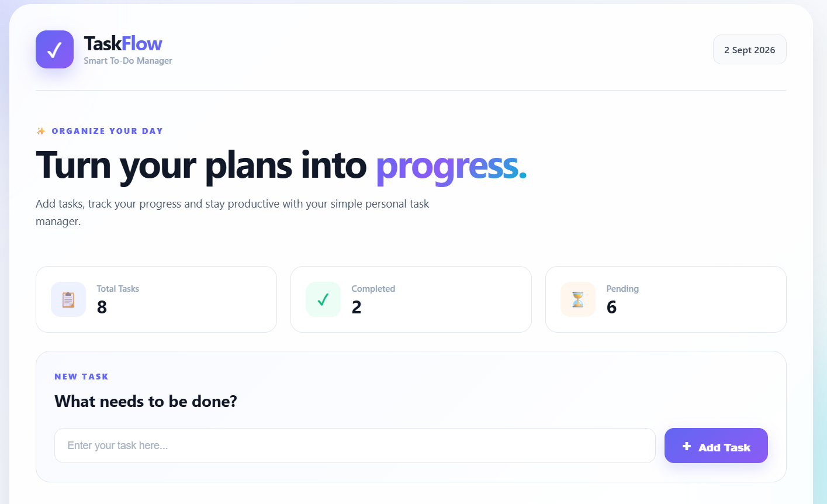

Figure 2: Tasks Fetched Using Fetch API
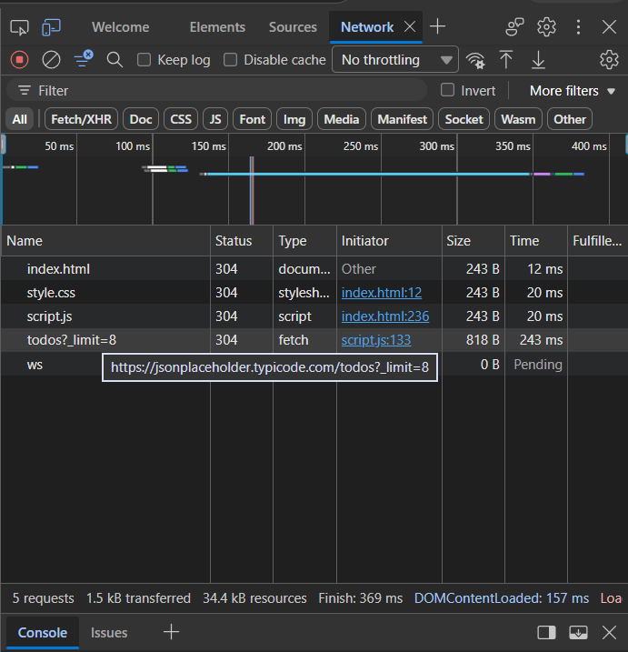

Course Title | Full Stack Web Development | Academic Year : 2026– 27 – Odd Sem
Course Code | 25SC2008E | Page 24 of 75

Figure 3 – Adding New Task

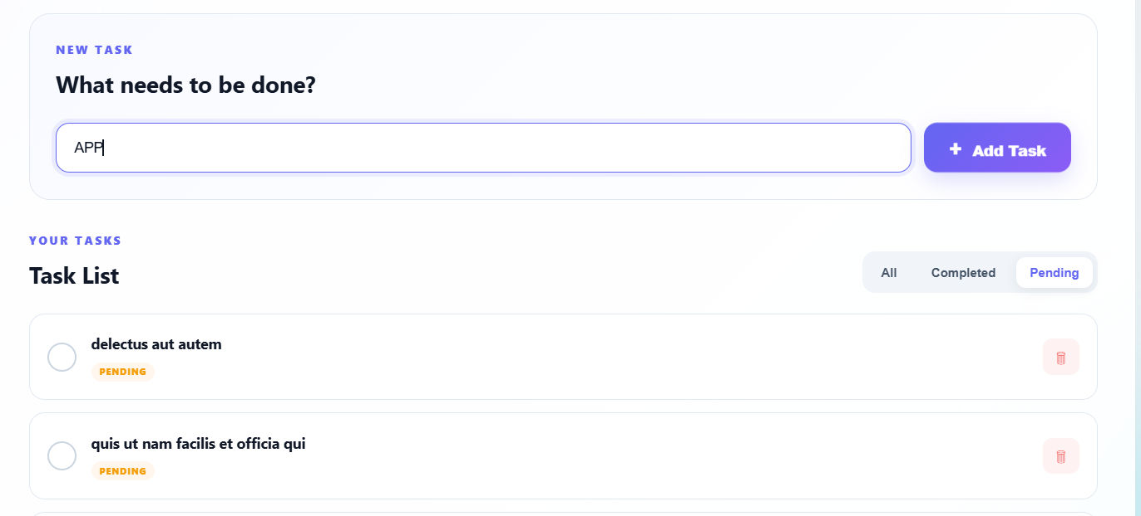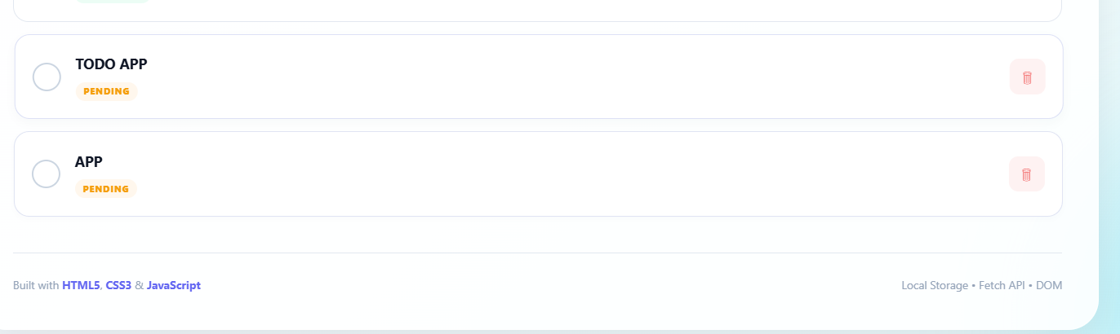

Figure 4: Task Status and Filtering

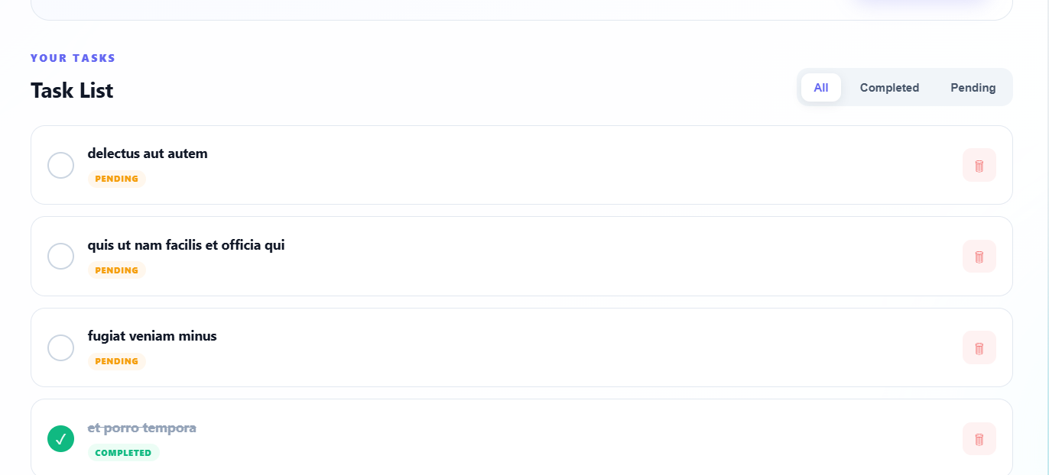

Course Title | Full Stack Web Development | Academic Year: 2026 – 27 – Even Sem
Course Code | 25SC2008E | Page 25 of 75

FIGURE-5: Responsive Mobile View

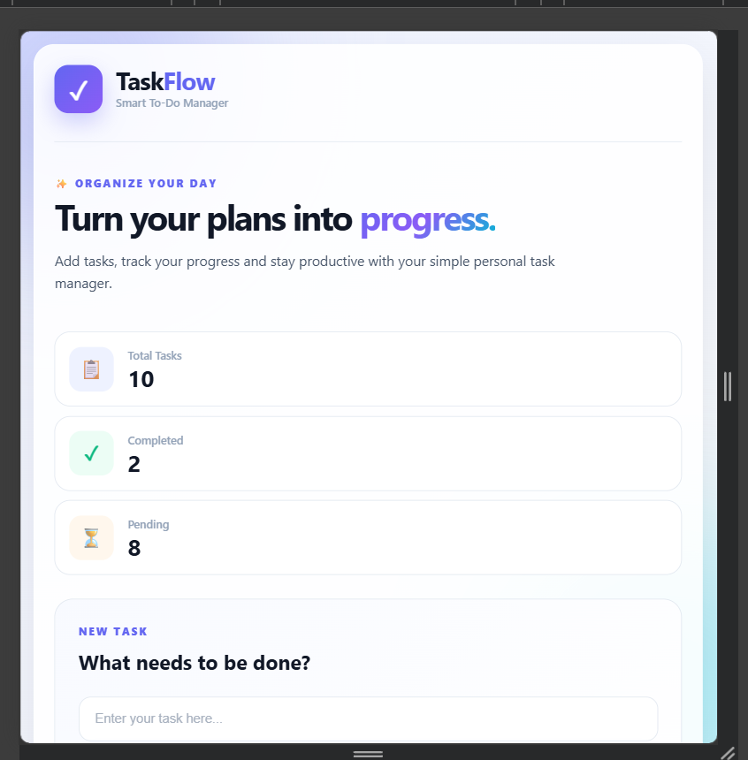

Course Title | Full Stack Web Development | Academic Year : 2026– 27 – Odd Sem
Course Code | 25SC2008E | Page 26 of 75

VIVA QUESTIONS AND ANSWERS

1. What is DOM Manipulation in JavaScript?

DOM Manipulation is the process of using JavaScript to access, modify,
add, or remove HTML elements and their content on a webpage. It allows
webpages to become dynamic and interactive.

Example:
document.getElementById("taskList");

2. What is the purpose of the Fetch API?

The Fetch API is used to send HTTP requests and retrieve data from
servers or online APIs. It is commonly used to fetch data without
reloading the webpage.

Example:
fetch("https://example.com/data");

3. Differentiate between Local Storage and Session Storage.

Local Storage:
- Stores data in the browser permanently until it is manually deleted.
- Data remains available even after closing and reopening the browser.
- It is suitable for storing user-created tasks.

Session Storage:
- Stores data only for the current browser tab or session.
- Data is removed when the browser tab is closed.
- It is suitable for temporary data.

Difference:
Local Storage → Persistent data
Session Storage → Temporary session data

4. How can data be retrieved from Local Storage?

Data can be retrieved from Local Storage using the
localStorage.getItem() method.

Example:
const data = localStorage.getItem("tasks");

If the stored data is in JSON format, JSON.parse() can be used to
convert it back into a JavaScript object or array.

Example:
const tasks = JSON.parse(localStorage.getItem("tasks"));

5. What is JSON and why is it used in API communication?

JSON stands for JavaScript Object Notation. It is a lightweight format
used to store and exchange data between a client and a server.

Course Title | Full Stack Web Development | Academic Year : 2026– 27 – Odd Sem
Course Code | 25SC2008E | Page 27 of 75

JSON is commonly used in API communication because it is simple,
easy to read, and can be easily converted into JavaScript objects.

6. Explain the working of addEventListener().

addEventListener() is a JavaScript method used to attach an event to
an HTML element. When the specified event occurs, a function is
executed.

Example:
button.addEventListener("click", function() {
alert("Button clicked!");
});

Here, the function runs when the button is clicked.

7. How do you dynamically create HTML elements using JavaScript?

HTML elements can be created dynamically using
document.createElement(). The element can then be modified and added
to the webpage using methods such as appendChild().

Example:
const item = document.createElement("div");
item.textContent = "New Task";
document.body.appendChild(item);

This creates and displays a new HTML element dynamically.

8. What is the purpose of response.json() in Fetch API?

response.json() is used to read the response from a Fetch API request
and convert the JSON data into a JavaScript object or array.

Example:
fetch("https://example.com/data")
.then(response => response.json())
.then(data => {
console.log(data);
});

It makes the JSON response easy to use in JavaScript.

Evaluator Remark (if Any): | Marks Secured:
Evaluator Remark (if Any): | Signature of the Evaluator with Date

Course Title | Full Stack Web Development | Academic Year: 2026 – 27 – Even Sem
Course Code | 25SC2008E | Page 28 of 75

Experiment 5: Node.js & Express ,middleware, routing, and REST API endpoints 25

Scenario:
A college wants to develop a simple Student Management Service to maintain student records. The backend system should provide REST API endpoints to add, view, update, and delete student information. The application must use Express routing and middleware for request processing and
logging. Students are required to build a backend service using Node.js and Express.js implementing
middleware, routing, and RESTful APIs.

Task 1: Create Node.js Project
Initialize a Node.js project.

Task 2: Create Express Server
Develop a basic Express server running on port 3000.
- Import Express module
- Create Express application
- Configure server listening port

Task 3: Implement Middleware
Create middleware functions for:
- Request logging
- Timestamp generation
- JSON request parsing

Task 4: Create REST API Routes

Implement the following routes:

Method | Endpoint | Description
GET | /students | Retrieve all students
GET | /students/:id | Retrieve student by ID
POST | /students | Add a student
PUT | /students/:id | Update student details
DELETE | /students/:id

Course Title | Full Stack Web Development | Academic Year: 2026 – 27 – Even Sem
Course Code | 25SC2008E | Page 25 of 75

Viva Questions:

- What is Node.js?

- What is Express.js and why is it used?

- What is middleware in Express?

- Differentiate between GET and POST methods.

Course Title | Full Stack Web Development | Academic Year: 2026 – 27 – Even Sem
Course Code | 25SC2008E | Page 26 of 75

Evaluator Remark (if Any): | Marks Secured:
Evaluator Remark (if Any): | Signature of the Evaluator with Date

Course Title | Full Stack Web Development | Academic Year: 2026 – 27 – Even Sem
Course Code | 25SC2008E | Page 27 of 75

Course Title | Full Stack Web Development | Academic Year: 2026 – 27 – Even Sem
Course Code | 25SC2008E | Page 28 of 75

Date of Execution:

Experiment 6: Student Management REST API using Express.js

A university requires a backend system to manage student information efficiently.
The system should allow administrators to add, retrieve, update, and delete student records through REST API endpoints.
Students are required to develop a Student Management REST API using Node.js and Express.js implementing CRUD operations and testing them using Postman or Thunder Client.
Project Structure:

student-management-api
│
├── server.js
├── routes
│ └── students.js
└── package.json

Task 1: Validate Requests
Implement validations:
- Name cannot be empty
- Department cannot be empty
- Year must be between 1 and 4
- Email should be valid

Task 2: Implement Error Handling
Handle:
  - Student Not Found
  - Invalid Routes
  - Invalid Request Body

Task 3: API Testing
Test all endpoints using:
- Postman
- Thunder Client
- VS Code REST Client Verify:
- Create Student
- View Student
- Update Student
- Delete Student

Course Title | Full Stack Web Development | Academic Year : 2026 – 27 – Odd Sem
Course Code | 25SC2008E | Page 29 of 75

Course Title | Full Stack Web Development | Academic Year : 2026– 27 – Odd Sem
Course Code | 25SC2008E | Page 30 of 75

Viva Questions:
- What is REST API?

- Explain CRUD operations.

- What is the purpose of app.use()?

- Difference between route parameters and query parameters.

- How can errors be handled in Express applications?

- Why is JSON widely used in REST APIs?

Course Title | Full Stack Web Development | Academic Year : 2026 – 27 – Odd Sem
Course Code | 25SC2008E | Page 31 of 75

Evaluator Remark (if Any): | Marks Secured:
Evaluator Remark (if Any): | Signature of the Evaluator with Date

Course Title | Full Stack Web Development | Academic Year : 2026 – 27 – Odd Sem
Course Code | 25SC2008E | Page 32 of 75

Date of Execution:

Experiment 7: Notes Management REST API with CRUD Operations using Node.js and Express.js
Scenario:
A software company wants to develop a Notes Management System that allows users to create, view, update, and delete personal notes. The backend service should expose REST API endpoints to manage notes efficiently.
Students are required to develop a Notes Management REST API using Node.js and Express.js, implementing CRUD operations with proper routing, middleware, request validation, and error handling.

Tasks:
Task 1:

Create Express Server
Develop an Express server that:
- Runs on Port 3000
- Accepts JSON requests
- Displays a startup message

Task 2:
Design Notes Data Structure

Each note should contain: JSON
{
"id": 1,
"title": "Meeting Notes",
"content": "Discuss project milestones", "createdAt": "2026-07-20"
}
Store notes using an in-memory array.

Expected Output:

View All Notes
HTTP
GET /notes Show more lines

Returns all notes.

Course Title | Full Stack Web Development | Academic Year : 2026 – 27 – Odd Sem
Course Code | 25SC2008E | Page 34 of 75

Course Title | Full Stack Web Development | Academic Year : 2026 – 27 – Odd Sem
Course Code | 25SC2008E | Page 35 of 75

Course Title | Full Stack Web Development | Academic Year : 2026 – 27 – Odd Sem
Course Code | 25SC2008E | Page 36 of 75

 | Evaluator Remark (if Any): |  | Marks Secured:
 |  |  | Signature of the Evaluator with Date
Course Title |  | Full Stack Web Development |  | Academic Year : 2026 – 27 – Odd Sem
Course Code |  | 25SC2008E |  | Page 37 of 75

25SC2008E- Full Stack Web Development – Lab

Date of Execution

Experiment 8: Product Catalog using MongoDB and Mongoose.

Scenario

An e-commerce company wants to maintain a Product Catalog Management System to store and manage information about products available for sale. The system should allow administrators to add, view, update, search, and delete products from a MongoDB database.
Students are required to develop a backend application using Node.js, Express.js, MongoDB, and Mongoose to perform CRUD operations on product data.
Tasks
Connect MongoDB Database
Create a connection to:

MongoDB Local Server OR MongoDB Atlas Cloud Database

Verify successful database connection.
Validate Requests
Ensure:

Product Name is mandatory. Price cannot be negative.
Stocks cannot be negative.
Duplicate Product IDs are not allowed.
 | Course Title | Full Stack Web Development | Academic Year : 2026 – 27 – Odd Sem
 | Course Code | 25SC2008E | Page 38 of 75

Course Title | Full Stack Web Development | Academic Year : 2026 – 27 – Odd Sem
Course Code | 25SC2008E | Page 39 of 75

Course Title | Full Stack Web Development | Academic Year : 2026 – 27 – Odd Sem
Course Code | 25SC2008E | Page 40 of 75

Viva Questions:

Course Title | Full Stack Web Development | Academic Year : 2026 – 27 – Odd Sem
Course Code | 25SC2008E | Page 41 of 75

Course Title | Full Stack Web Development | Academic Year : 2026 – 27 – Odd Sem
Course Code | 25SC2008E | Page 42 of 75

Evaluator Remark (if Any): | Marks Secured:
Evaluator Remark (if Any): | Signature of the Evaluator with Date

Course Title | Full Stack Web Development | Academic Year : 2026 – 27 – Odd Sem
Course Code | 25SC2008E | Page 43 of 75

Date of Execution:
Experiment 9: Create a Movie Collection CRUD Application with Database Integration

Scenario
An online movie streaming company wants to maintain a Movie Collection Management System to store and manage information about movies available on its platform. The system should allow administrators to add, view, update, search, and delete movie records stored in a database.
Students are required to develop a CRUD application using Node.js, Express.js, and MongoDB (Mongoose) or PostgreSQL (Prisma).

Tasks
Task 1
Create a database and connect it with an Express.js application.

Task 2
Design a Movie Schema/Table with the following fields:
- Movie ID
- Movie Title
- Genre
- Release Year
- Language
- Rating

Task 3
Validate Inputs:
- Movie Title cannot be empty.
- Genre is mandatory.
- Release Year must be valid.
- Rating should be between 1 and 10.
Test all CRUD APIs using Postman or Thunder Client and verify that movie records persist after restarting the server.

Course Title | Full Stack Web Development | Academic Year : 2026 – 27 – Odd Sem
Course Code | 25SC2008E | Page 44 of 75

Course Title | Full Stack Web Development | Academic Year : 2026 – 27 – Odd Sem
Course Code | 25SC2008E | Page 45 of 75

Course Title | Full Stack Web Development | Academic Year : 2026 – 27 – Odd Sem
Course Code | 25SC2008E | Page 46 of 75

Course Title | Full Stack Web Development | Academic Year : 2026 – 27 – Odd Sem
Course Code | 25SC2008E | Page 47 of 75

Course Title | Full Stack Web Development | Academic Year : 2026 – 27 – Odd Sem
Course Code | 25SC2008E | Page 48 of 75

Date of Execution:
Experiment 10 : Student Record Management System using MongoDB Atlas

Scenario
A university has developed a Student Management REST API using Express.js to manage student records. Currently, student data is stored in temporary arrays, causing all records to be lost whenever the server restarts.

The university administration wants a permanent solution where student records are stored in a cloud-hosted database such as MongoDB Atlas or PostgreSQL using Prisma ORM. The system should support adding, viewing, updating, deleting, and searching student records while ensuring data persistence even after server shutdown and restart.
As a Full Stack Developer, integrate the Student Management API with MongoDB Atlas or PostgreSQL and verify persistent storage.

Course Title | Full Stack Web Development | Academic Year : 2026 – 27 – Odd Sem
Course Code | 25SC2008E | Page 49 of 75

Course Title | Full Stack Web Development | Academic Year : 2026 – 27 – Odd Sem
Course Code | 25SC2008E | Page 50 of 75

Course Title | Full Stack Web Development | Academic Year : 2026 – 27 – Odd Sem
Course Code | 25SC2008E | Page 51 of 75

Course Title | Full Stack Web Development | Academic Year: 2026 – 27 – Odd Sem
Course Code | 25SC2008E | Page 52 of 75

Evaluator Remark (if Any): | Marks Secured:
Evaluator Remark (if Any): | Signature of the Evaluator with Date

Course Title | Full Stack Web Development | Academic Year: 2026 – 27 – Odd Sem
Course Code | 25SC2008E | Page 53 of 75

Date of Execution:
Experiment 11 : Integrate MongoDB Atlas/PostgreSQL (Prisma) with Express API and Verify Persistent Data Storage for Student Management

Scenario
A university has developed a Student Management REST API using Express.js to manage student records. Currently, student data is stored in temporary arrays, causing all records to be lost whenever the server restarts. The university administration wants a permanent solution where student records are stored in a cloud-hosted database such as MongoDB Atlas or PostgreSQL using Prisma ORM. The system should support
adding, viewing, updating, deleting, and searching student records while ensuring data persistence even after server shutdown and restart.
As a Full Stack Developer, integrate the Student Management API with MongoDB Atlas or PostgreSQL and verify persistent storage.

TASKS

Configure Database Connection Using MongoDB Atlas
- Create a MongoDB Atlas account.
- Create a cluster.
- Create a database user.
- Obtain the connection string.
- Store it in the .env file.
PostgreSQL + Prisma

- Create PostgreSQL database named studentdb.
- Initialize Prisma.

Validate User Input
Validate:
  - Student Name Cannot Be Empty
  - Department Cannot Be Empty
  - Year Must Be Between 1 and 4
  - Valid Email Address Required Display appropriate error messages.

Course Title | Full Stack Web Development | Academic Year: 2026 – 27 – Odd Sem
Course Code | 25SC2008E | Page 54 of 75

Course Title | Full Stack Web Development | Academic Year: 2026 – 27 – Odd Sem
Course Code | 25SC2008E | Page 55 of 75

Course Title | Full Stack Web Development | Academic Year: 2026 – 27 – Odd Sem
Course Code | 25SC2008E | Page 56 of 75

Evaluator Remark (if Any): | Marks Secured:
Evaluator Remark (if Any): | Signature of the Evaluator with Date

Course Title | Full Stack Web Development | Academic Year: 2026 – 27 – Odd Sem
Course Code | 25SC2008E | Page 58 of 75

Date of Execution:
Experiment 12 : JWT-Based Authentication with User Registration, Login, Password Hashing (bcrypt), and Protected Routes

Scenario
A university develops a Student Portal Application that allows students to access academic information online. To ensure security, only registered users should be able to log in and access protected resources. User passwords must be stored securely using bcrypt hashing, and authenticated users should receive a JWT token to access protected routes.
Students are required to develop a secure authentication system using Node.js, Express.js, JWT, and bcrypt.

Task 1

Create a User Schema with the following fields:
- Name
- Email
- Password
- Role (Student/Admin)

Task 2

Implement User Registration API

Test all APIs using Postman and verify:
- User Registration
- Password Hashing
- User Login
- JWT Token Generation
- Access to Protected Routes

Course Title | Full Stack Web Development | Academic Year: 2026 – 27 – Odd Sem
Course Code | 25SC2008E | Page 59 of 75

Viva Questions
  - What is JWT and why is it used for authentication?

  - Why should passwords be hashed using bcrypt instead of storing them in plain text?

  - What is the difference between Authentication and Authorization?

  - What are protected routes and how are they secured using JWT?

  - What are the three parts of a JSON Web Token (JWT)?

Course Title | Full Stack Web Development | Academic Year: 2026 – 27 – Odd Sem
Course Code | 25SC2008E | Page 60 of 75

Course Title | Full Stack Web Development | Academic Year: 2026 – 27 – Odd Sem
Course Code | 25SC2008E | Page 61 of 75

Course Title | Full Stack Web Development | Academic Year : 2026 – 27 – Odd Sem
Course Code | 25SC2008E | Page 62 of 75

Evaluator Remark (if Any): | Marks Secured:
Evaluator Remark (if Any): | Signature of the Evaluator with Date

Course Title | Full Stack Web Development | Academic Year : 2026 – 27 – Odd Sem
Course Code | 25SC2008E | Page 63 of 75

Date of Execution:
Experiment 13: Deploy React Frontend on Vercel and Node.js Backend on Render/Railway with Environment Variable Configuration

Scenario
A software development team has completed a Full Stack Student Management Application consisting of a React frontend and a Node.js/Express backend.
To make the application accessible to users worldwide, the team must deploy the frontend on Vercel and the backend on Render/Railway. Sensitive information
such as database URLs, JWT secrets, and API keys must be managed securely using environment variables. Students are required to deploy the application, configure environment variables,
and verify end-to-end communication between frontend and backend services.

Tasks Task 1

Task 2

Task 3

Task 4

Create GitHub repositories and push the React frontend and Node.js backend code. Deploy the React application on Vercel.
- Connect GitHub repository.
- Configure build settings.
- Generate deployment URL.

Deploy the Node.js/Express API on Render or Railway.
- Connect backend repository.
- Configure start command.
- Deploy backend service.

Configure Environment Variables.
Test application functionality after deployment. Verify:
- Frontend accessible through Vercel URL.
- Backend accessible through Render/Railway URL.
- Database connectivity working properly.
- Environment variables loaded successfully.

Course Title | Full Stack Web Development | Academic Year : 2026 – 27 – Odd Sem
Course Code | 25SC2008E | Page 64 of 75

Course Title | Full Stack Web Development | Academic Year : 2026 – 27 – Odd Sem
Course Code | 25SC2008E | Page 65 of 75

Evaluator Remark (if Any): | Marks Secured:
Evaluator Remark (if Any): | Signature of the Evaluator with Date

Course Title | Full Stack Web Development | Academic Year : 2026 – 27 – Odd Sem
Course Code | 25SC2008E | Page 67 of 75

Experiment 14 : Deploy React Frontend on Vercel and Node.js Backend on Render/Railway with Environment Variable Configuration

Scenario/Problem Statement of Project:

Review 1: Problem Analysis & Design (50 Marks)
S.No | Parameter | Marks Awarded/Max marks
1 | Problem Identification and Requirement Analysis | /10
2 | Event Registration Workflow Design | /10
3 | Database Schema Design (Users, Events, Registrations) | /10
4 | Prototype Preparation | /10
5 | Team Coordination and Documentation | /10
Total |  | /50

Course Title | Full Stack Web Development | Academic Year : 2026 – 27 – Odd Sem
Course Code | 25SC2008E | Page 68 of 75

Review 2: Frontend Development (50 Marks)
S.No | Parameter | Marks Awarded/Max marks
1 | React Project Setup and Component Structure | /10
2 | User Registration and Login Pages | /10
3 | Event Listing and Registration Interface | /10
4 | Responsive Design and User Experience | /10
5 | GitHub Repository Maintenance | /10
Total |  | /50

Review 3: Backend API & Authentication (50 Marks)
S.No | Parameter | Marks
1 | Express Server Configuration | 10
2 | REST API Development (Users, Events, Registrations) | 10
3 | JWT Authentication Implementation | 10
4 | Password Hashing using bcrypt | 10
5 | Error Handling and Middleware Usage | 10
Total |  | 50

Course Title | Full Stack Web Development | Academic Year : 2026 – 27 – Odd Sem
Course Code | 25SC2008E | Page 69 of 75

Review 4: Database Integration & System Functionality (50 Marks)

S.No | Parameter | Marks
1 | MongoDB Atlas/PostgreSQL Integration | 10
2 | CRUD Operations with Persistent Storage | 10
3 | User Registration and Login Functionality | 10
4 | Event Registration and Management Features | 10
5 | End-to-End System Integration Testing | 10
Total |  | 50

Course Title | Full Stack Web Development | Academic Year: 2026 – 27 – Odd Sem
Course Code | 25SC2008E | Page 70 of 75

Review 5: Deployment & Final Demonstration (50 Marks)
S.No | Parameter | Marks
1 | Frontend Deployment on Vercel | 10
2 | Backend Deployment on Render/Railway | 10
3 | Environment Variable Configuration | 10
4 | CI/CD Using GitHub Actions | 10
5 | Final Demonstration, Documentation & Presentation | 10
Total |  | 50

Course Title | Full Stack Web Development | Academic Year : 2026 – 27 – Odd Sem
Course Code | 25SC2008E | Page 71 of 75

Course Title | Full Stack Web Development | Academic Year: 2026 – 27 – Odd Sem
Course Code | 25SC2008E | Page 72 of 75

Project Viva Questions
- What is JWT and how is it used for authentication?

- Why is bcrypt used for password hashing?

- What is the difference between Authentication and Authorization?

- Explain the complete flow of Event Registration in your application.

- How is React connected to the Express backend?

Course Title | Full Stack Web Development | Academic Year: 2026 – 27 – Odd Sem
Course Code | 25SC2008E | Page 73 of 75

Project Viva Questions

- How is data stored in MongoDB Atlas/PostgreSQL?

- What are protected routes and how are they implemented?

- Why are environment variables required during deployment?

- What challenges did you face during deployment?

- How does GitHub Actions automate CI/CD workflows?

Course Title | Full Stack Web Development | Academic Year: 2026 – 27 – Odd Sem
Course Code | 25SC2008E | Page 74 of 75

Final Project Evaluation Rubric (100 Marks)

Component | Marks
Requirement Analysis & Design | 10
Frontend Development | 20
Backend API Development | 20
Authentication & Authorization | 15
Database Integration | 15
Deployment & CI/CD | 10
Project Demonstration & Viva | 10
Total | 100

Course Title | Full Stack Web Development | Academic Year: 2026 – 27 – Odd Sem
Course Code | 25SC2008E | Page 75 of 75

